FEASIBILITY STUDY

NPO PHENIKS

INTERNATIONAL TECHNICAL
&
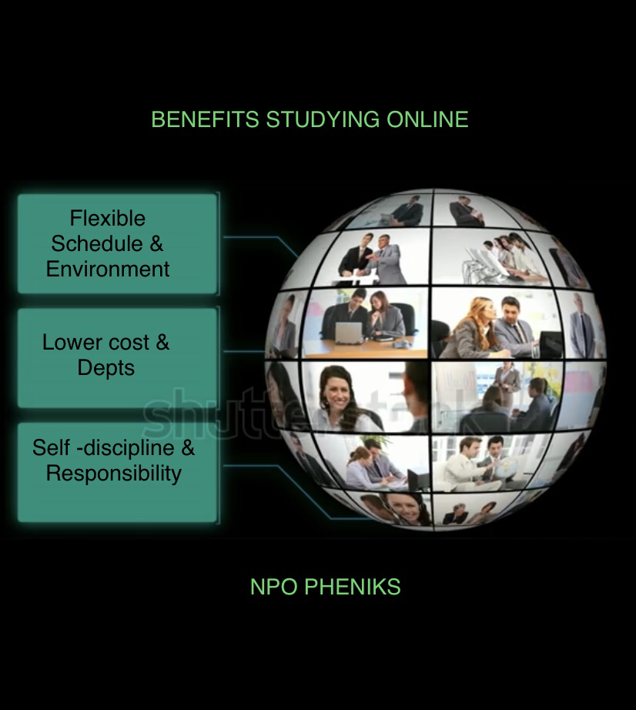
VOCATIONAL ONLINE EDUCATION
NPO PHENIKS
Company number : 12947826
Director : DIYAN YANCHEV
Address : STUDIO 210 , 134-146 CURTIN ROAD
LONDON , EC2A 3AR

Feasibility Study

FEASIBILITY STUDY

International Technical and Vocational Online
Education
INTERNATIONAL TECHNICAL & VOCATIONAL ONLINE
EDUCATION
International Technical and Vocational Online

• identifies possible objectives, programme areas, structures and modalities of operation
Summary

This Study

• identifies possible objectives, programme areas, structures and modalities of operation
Summary

This Study

• analyses the feasibility of an International Technical and Vocational Online Education

• identifies possible objectives, programme areas, structures and modalities of operation

• examines the complementarity of its possible tasks with those of other international institutions.

The situation prevailing in the developing world has been duly considered, particularly when identifying possible programme areas and modalities of work.
• examines the complementarity of its possible tasks with those of other international

Four programme areas are identified:
The establishment of an International Technical and Vocational Online Education for the purpose of promoting and supporting the development of national technical and vocational education systems is both feasible and highly desirable.

Four programme areas are identified:

• Exchanges of ideas and experience, and studies on policy issues

• Strengthening of national research and development capabilities

• Promotion of innovation in staff development

International co-operative action,

Priorities for action and modalities of operation are suggested.

Lastly, consideration is given to questions pertaining to institutional arrangements, management, financing, and criteria for location of main office to International Technical and Vocational Online Education.
• Exchanges of ideas and experience, and studies on policy issues

Introduction

Technical and vocational online education is normally furnished within education systems, while training aimed at development of skills and capabilities directly related to work situations is often imparted by specialised governmental and public institutions (apprenticeship services, ministries other than education, etc.) or by the enterprises themselves.

The importance of technical and vocational online education is enhanced by increasing social demand and the ever-growing technological component of human activities. In the past few decades productive activities have evolved significantly, mainly because of automation of operations, robotisation, computerised control, development of new materials, more efficient use of energy, and innovative organisation patterns of production. This evolution entails a general shift from manual skills towards technical knowledge, and the advent of new fields of competence at all levels. Social demand calls for emphasis on job creation and training for self-employment. In all, significant changes in the occupational profile take place continuously, coupled to expansion of technology-based activities.

Technical and vocational online education has to evolve and expand accordingly, and this poses problems of various kinds. Addressing them is more difficult in developing countries than in the industrialised world: awareness of technical advances and their impact on technical and vocational education and on qualifications of the human resources required may be not the same; enrolment in technical and vocational education in developing countries expands at a faster pace, and the human and material resources are often insufficient or not up to standards.
• Strengthening of national research and development capabilities

• Promotion of innovation in staff development
The considerable inertia of most education systems exacerbates the problem, although there is growing awareness that

• flexible schemes of education and training are more adaptable to meet evolving demands than traditional approaches and will be easy to show them trough online innovations.

• broad, conceptual understanding of the techniques and skills proper of each technical field or trade facilitates occupational mobility and continuing education;

• close interaction between technical and vocational education and the productive sector is nowadays indispensable to ensure relevance of the education and training processes and facilitate integration of the school leavers in the world of work;

• research on the above matters and action on the corresponding issues require awareness of the problematic, availability of information and data, and the possibility of drawing from existing experience elsewhere. the assumption of public responsibility for the framing of policies and the definition of strategies for technical and vocational education, considered to be an integral part of the education system and the promotion of international cooperation . Scope of technical and vocational education

​Definition of technical and vocational online education

1. Education and training for employment knowledge and skills with the purpose of social equity, inclusion, and sustainable development. Learn more in digital technologies .
According to Department of Education, technical schools teach the theory and science behind the occupation, while vocational schools take a more hands-on approach to teaching the skills needed to do the job successfully. TECHNICAL-VOCATIONAL ONLINE EDUCATION AND TRAINING is the education or training process where it involves, in addition to general education, the study of technologies and related science and acquisition of practical skills relating to occupations in various sectors of economic life and social life, comprises formal

The technical and vocational education and training is particularly important for promoting economic development, expanding employment size and improving the quality of employment.

Vocational skills typically refers to occupations that you can learn with some basic training or on-the-job in lieu of a college degree. Electricians, truck drivers, hair stylists, medical records technicians and emergency medical technicians are some examples of occupations with vocational skills.
Choosing a technical online education has five advantages.
* Financial Benefits. A degree or a diploma from a technical online course costs much less than a degree from a four-year college. ...
* Career Focus. ...
* Smaller Classes. ...
* Adaptability. ...
* Career Advice.

Vocational online education refers to initial or further vocational education leading to a vocational qualification. ... These are always preparatory education for a skills examination and the qualifications are based on skills examinations. List of Vocational Subjects:
* Office Secretary ship. a. Office Practice and Secretary ship. ...
* Stenography & Computer Application. a. Typewriting (English) ...
* Accountancy and Auditing. a. Financial Accounting. ...
* Marketing and Salesmanship. a. Marketing. ...
* Banking. a. Cash Management and House Keeping. ...
* Electrical Technology. a. Engineering Science. ...
* Automobile Technology….Relevant aspects

A broad concept of technical and vocational education

For the purpose of this study, it is pertinent to note that:

• Firstly, the term technical and vocational online education refers to education processes of all types and at all levels (from secondary to post-secondary level) intended to provide technological knowledge and practice-oriented qualification related to the world of work.

• Secondly, technical and vocational education comprises formal and non-formal education, the latter through co-operative programmes with the productive sector, that is, closely related to the formal approach proper of an institutionalised technical and vocational education system.

• Thirdly, imparting technical and vocational education implies responsibilities on the part of government agencies, and also of private undertakings (industrial/craft, commercial, service, agricultural, etc.), particularly in so far as programmes catering to the occupational market are concerned.

• Fourthly, technical and vocational education is a life-long undertaking of particular relevance, aimed at development of individuals and societies in a world in continuous and dynamic evolution, particularly in the field of technology.

This fourth remark points at the fact that technical and vocational online education caters not only to objectives stemming from occupational considerations, but also to the development of the individual in increasingly technology-oriented societies. In fact, technology is nowadays an aspect of culture, and as such it is finding a place in general education in many countries.
Figure 1 presents succinctly the scope of technical and vocational education as depicted above:

Range of technical and vocational online
education
 | from ... | to ...
level | secondary level | post-secondary level
type | formal | non-formal
responsibility | government | co-operative government/private
individual life span | initial training of young people | advanced technical training of adults
educational | individual development | occupational capabilities
objective
 | Figure 1
 | Breadth of scope of technical and vocational education

Basic elements for the system design and development of technical and vocational online education systems

• Policies concerning technical and vocational education should be set within the framework provided by education policies in general;

Integration with other types of education implies horizontal and vertical articulation, that is, ensuring permeability stemming from transfer mechanisms among the various streams and levels;

• Introduction to technology and to the world of work within the context of general education online;

• Equal access for all and social openness and consideration of the special needs of disadvantaged groups should be ensured;
•

• Orientation of technical and vocational online education according to the specific socio-economic context prevailing in each case hinges inter alia on ;

- adaptability to follow the inevitable evolution of the occupational profiles and market;

— incorporation of new knowledge and technical developments;

— possibility of fostering employment and enabling self-employment;

— response to cultural, social and ecological conditions; Training of teaching staff, instructors etc

Justification and possible objectives of an International Technical and Vocational Online Education

Justification

Reference has been made in the Introduction to the growing demand for technical and vocational education. Special emphasis has been laid on the nature and pace of technological advances, which have important effects on the occupational profile everywhere, and therefore on qualitative and content aspects of the education/training process. The needs thus created for modernisation and expansion of technical and vocational education, especially in the developing countries, call for increased national and international efforts.
Taking into consideration

• the need for increased international co-operation and

• the dynamics which can be originated by a tailor-made institutional framework.

​Programme Areas

Development of technical and vocational online education within a given context hinges on properly addressing policy and delivery issues. The first concern framework aspects such as legislation, structure, social aims, distribution of responsibilities including social partners, target population, etc. The second concern the educational process and all that makes it relevant and productive, such as study plans, balance among subjects, staff development, and management at institutional level. In principle, the Centre should work with key national institutions and personnel involved in policy and decision-making, research, innovation and staff development.

The programme areas proposed are:

Programme Areа
A Exchanges of ideas and experience, and studies on policy issues

B Strengthening of national research and development capabilities

C
Promotion of innovation in staff development

D
Facilitating access to data bases and documentation

E
International co-operative action

Proposed Programme Areas for an International Technical and Vocational Education

Substantive content of the Programme Areas

An outline of the Programme Areas refers to possible modalities for implementation
.

A​ Exchanges of ideas and experience, and studies on policy issues

Development of technical and vocational education systems, such as:

• research policies in technical and vocational education,

• framework aspects of system development,

• models of curriculum development,

• promotion of access of women to technical and vocational education,

• consideration of science and technology advances and their effect on occupational profiles,

• professionalisation of technical and vocational education personnel.

B​ Strengthening of national research and development capabilities

• development of infrastructures,

• basic and continuing studies for researchers,

• implementation of research projects of regional scope,

• evaluation of performance of the teaching process,

• dissemination of research findings,

• utilisation of software and hardware.

C​ Promotion of innovation in staff development

Seminars, short intensive courses, workshops, and study visits for high level staff would be considered under this programme area, focusing on delivery aspects, such as

• application of new technologies in education/training, e.g. computer assisted instruction, etc.

• curriculum development and evaluation,

• productive activities linked with study/training,

• school laboratory and workshop management,

• preparation of teaching/training materials,

• assessment of practical training, and

• introduction of innovations in methodology, e.g. modular approach.

Existing facilities would be utilised, to the extent possible, in co-operation with other specialised institutions.

D​ Facilitating access to data bases and documentation

• access to data available on technical and vocational education according to specific needs of the countries concerned,

• interpretation and application of data on subjects relevant to development of technical and vocational online education.

E​ International co-operative action

• initial and continuing technical and vocational education programmes,

• co-operative research, pilot projects, and training,

• the transfer of structures, models, teacher and related experiences. Symposia on planning and policy issues

on policy issues
• Assessment projects

• Expertise, e.g. on cost-effectiveness

Programme Areas

It is recommended to undertake the implementation of Programme Areas B (Strengthening of national research and development capabilities) and D (Facilitating access to data bases and documentation) as soon as possible, given the importance of the ensuing application for the development of technical and vocational education systems.

Building up substantive competence and structures at the calls for systematic, sustained efforts in order to enable the countries to reap tangible benefits from them. The most important ones would be the establishment of information data bases (which in turn calls for dedicated networking), and action related to strengthening national research capabilities. The latter may lead to useful application of results in the countries, at both structural and delivery levels.

Activities such as staff development (Programme Area C) are fundamental for developing countries, to improve qualitative and delivery aspects, that is, the efficiency of education/ training processes.

Execution depends on factors such as substantive interrelation among the activities, interest of the countries concerned and co-operative mechanisms for implementation, and availability of human and financial resources.

Management

The project should be carried out under the responsibility of a Director who would:

• administer the online Centre, within the general mandate invested in him

• propose to the Director-General a draft Programme and Budget on a biennial basic

• set up a work plan for the activities foreseen under the Programme and Budget,

• report to the Director-General on programme implementation and results obtained.

An advisory body would deal with matters submitted by the Director-General to its consideration, such as general orientation of the programme, priorities and modalities of operation, new lines of action, etc.

Staff

The staff for the initial phase should include, in addition to the Director,

• a senior research and programme specialist responsible for planning and co-ordination of the Centre's research network;

• professional staff conversant with technical and vocational online education development in the different regions of the world;

• a specialist in information and communication technologies who will establish and operate a computerised communication network among participating institutions,

• general services staff, in particular a documentarist, a staff member in charge of accounting, procure-men etc., and secretaries,

and in addition, on a temporary basis and as far as funds can be provided from external sources, specialists seconded from interested Member States as well as visiting fellows/associated experts from specialised international, regional and national institutions who will gain experience while contributing to the work of the Centre.

Location

The Centre will have limited human and material resources of its own. Therefore it appears indispensable for it to be placed within an environment contributing to the performance of its tasks. It would be desirable:

• for the host country to have a highly developed system of technical and vocational online education, with a variety of resource persons available;

• to create favourable conditions for the Centre to co-operate easily with Member States from all regions of the world and to establish operational linkages with institutions active in technical and vocational online education, particularly in the field of research and development;

• to have access to information bases such as specialised libraries and documentation centres, adequate conference facilities and efficient communication services. Cost: initial phase

Cost of establishing the Centre

This includes expenses, in particular investment, which will, in addition to current operational costs, occur in the initial phase, such as:

• preparation of facilities,

• furniture and office equipment,

• information and communication technology,

• documentation.

Operational Costs

Cost of operating the Centre comprises expenses required for execution of its programme, as well as the minimum expenditure for staff and support services.

The annual cost of operating the Centre will have to be worked out on the basis of additional information on the conditions that may prevail for launching the project. It is deemed, however, that the Centre would require, in its initial phase, an annual budget for staff and programme supporting services in the order of one million pounds (£1000000) . Direct programme cost would require resources in the order of one to two million £1000000-£2000000 .
Financing of both establishment and operational costs is anticipated from different sources, in particular

• contributions from the host country and/or institution, particularly towards the preparation, equipment and maintenance of facilities, and for staff and programme supporting services;

• allocations from international organisations and other donor agencies/foundations;

• voluntary contributions from governments, public or private organisations, associations or individuals;

• fees collected for special services offered by the Centre, e.g. sales of publications or consultancy.

Conclusio

Tentative estimate of annual cost of operation

Costs of operation will to a certain extent depend on factors such as the location, premises, etc. which cannot be anticipated. Therefore, only a tentative estimate can be produced based on assumed standards of remuneration in international organisations and on staff provisions given under Chapter 7.

Direct programme costs refer to activities to be carried out within the five Programme Areas.

Costs for staff and support services are related to the basic professional and administrative services, including minimum operating expenditure, such as documentation, travel, communication, etc.

It is considered that for the Centre to have the expected impact on the development of technical and vocational education systems, the following resources would be needed:
needed:

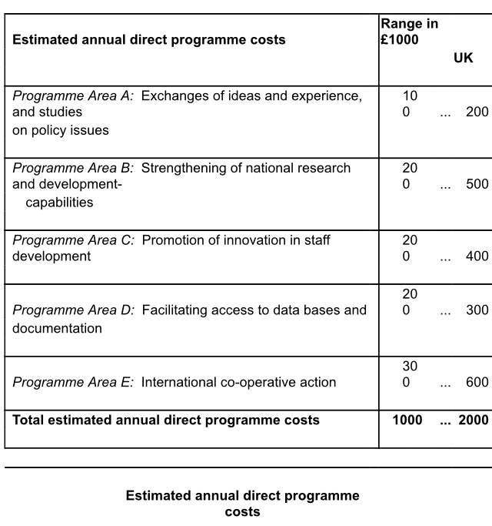
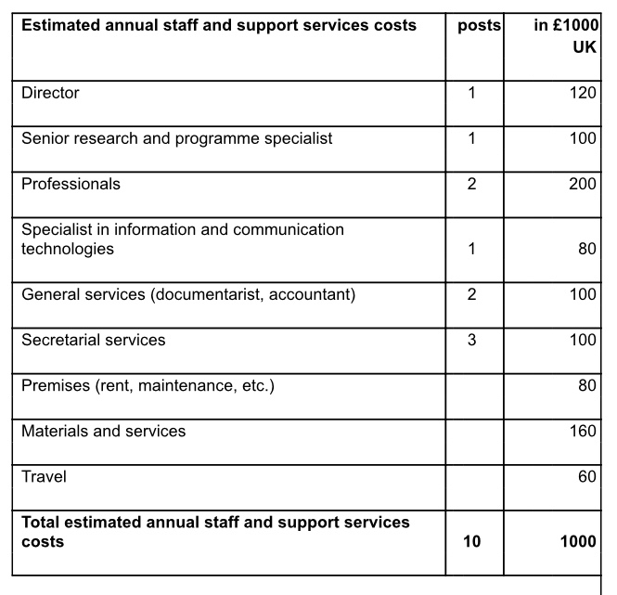
Estimated annual staff and support services cost

Conclusion

The world-wide problematic of technical and vocational online education is characterised by increasing demand in quantitative and qualitative terms, particularly in the light of rapid technological advances. The developing countries face special problems for modernisation and expansion of their technical and vocational online education due to inadequacy of research and development infrastructures and of technical and material resources.

The study concludes that the establishment of an International Centre for Technical and Vocational Online Education for the purpose of promoting and supporting the development of national systems of technical and vocational education is both feasible and highly desirable.

Modalities of work
Some possible modalities of work and instruments are listed

• examines the complementarity oSummary

